**PIZZA SALES SQL QUERIES**

**A. KPI’s**

**1. Total Revenue:**

select sum(total_price) as Total_Revenue from pizza_sales;

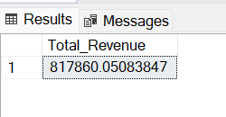

**2. Average Order Value:**

SELECT SUM(total_price) / COUNT(DISTINCT order_id) AS Avg_Order_Value FROM pizza_sales;

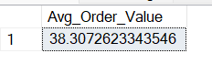

**3. Total Pizza Sold:**

SELECT SUM(quantity) AS Total_Pizza_Sold FROM pizza_sales;

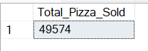

**4. Total Orders:**

SELECT COUNT(DISTINCT order_id) AS Total_Orders FROM pizza_sales;

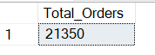

**5. Average Pizza Per Order:**

SELECT CAST(CAST(SUM(quantity) AS DECIMAL (10,2)) /

CAST(COUNT(DISTINCT order_id) AS DECIMAL (10,2)) AS DECIMAL (10,2)) as Avg_Pizzas_Per_Order FROM pizza_sales;

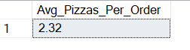

**B. DAILY TRENDS FOR TOTAL ORDERS**

SELECT DATENAME(DW, order_date) AS Order_Day , COUNT(DISTINCT order_id) AS Total_Orders

FROM pizza_sales

GROUP BY DATENAME(DW, order_date);

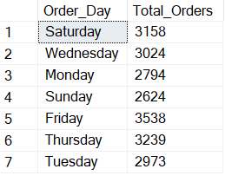

**C. HOURLY TRENDS FOR TOTAL ORDERS**

SELECT DATEPART(HOUR, order_time) AS Order_Hours, COUNT(DISTINCT order_id) AS Total_Orders

FROM pizza_sales

GROUP BY DATEPART(HOUR, order_time)

ORDER BY DATEPART(HOUR, order_time);

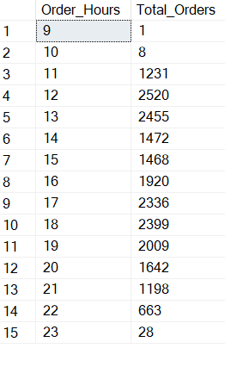

**D. % OF SALES BY PIZZA CATEGORY:**

SELECT pizza_category, CAST(SUM(total_price) AS DECIMAL (10,2)) AS Total_Revenue,

CAST(SUM(total_price) * 100 / (SELECT SUM(total_price) FROM pizza_sales) AS DECIMAL (10,2)) AS PCT

FROM pizza_sales

GROUP BY pizza_category

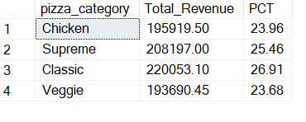

**E. % OF SALES BY PIZZA SIZE:**

SELECT pizza_size, CAST(SUM(total_price)AS DECIMAL (10,2)) AS Total_Revenue,

CAST(SUM(total_price) * 100 / (SELECT SUM(total_price) from pizza_sales) AS DECIMAL (10,2)) AS PCT

FROM pizza_sales

GROUP BY pizza_size

ORDER BY pizza_size;

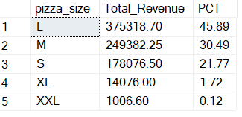

**F. TOTAL PIZZA SOLD BY PIZZA CATEGORY:**

SELECT pizza_category, SUM(quantity) AS Total_Pizzas_Sold

FROM pizza_sales

GROUP BY pizza_category;

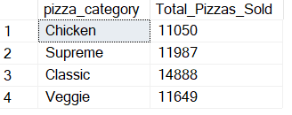

**G. TOP 5 BEST SELLERS BY TOTAL PIZZAS SOLD:**

SELECT TOP 5 pizza_name, SUM(quantity) AS Total_Pizzas_Sold

FROM pizza_sales

GROUP BY pizza_name

ORDER BY Total_Pizzas_Sold DESC;

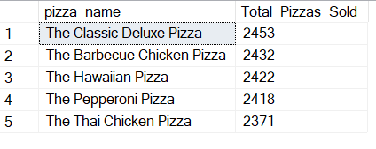

**H. BOTTOM 5 BEST SELLERS BY TOTAL PIZZAS SOLD:**

SELECT TOP 5 pizza_name, SUM(quantity) AS Total_Pizzas_Sold

FROM pizza_sales

GROUP BY pizza_name

ORDER BY Total_Pizzas_Sold ASC;

